CDAC-Mumbai  
Subject: ASDM  
Date:02-02-2023 Total Marks:30  
Time duration: 2:00hrs. Batch: Sep22  
--------------------------------------------------------------------------------------------------------------------  
Section I – Testing [20marks]  
NOTE: The code to test the web link given in question ,should make use of all the various  
applicable locators like Id, name, class, tagname, cssSelector, xpath, linktext, partial linktext to  
traverse the web element and do the needful steps in the question:  
Question :  
Write a Script to do following to test the https://www.slideshare.net/ website using Selenium  
a) Open the url [4marks]  
b) Go to SignUp [ 3marks]  
c) Perform Sign up [5marks]  
d) Search for datatstructure ppt [3marks]  
e) Open any one ppt [3marks]  
f) Print the title of page [2marks]

code

**package** session1;

**import** org.openqa.selenium.By;

**import** org.openqa.selenium.WebElement;

**import** org.openqa.selenium.chrome.ChromeDriver;

**public** **class** Script1 {

ChromeDriver driver;

**public** **void** open()

{

System.*setProperty*("webdriver.chrome.driver", "D:\\Coding CDAC\\Selenium\\Library\\chromedriver_win32\\chromedriver.exe");

driver=**new** ChromeDriver();

driver.get("https://www.slideshare.net/"); //open

driver.manage().window().maximize(); //maximise

driver.findElement(By.*cssSelector*("#signup-from-header")).click();

//signup with email

driver.findElement(By.*cssSelector*("<a data-e2e=\"email-button\" class=\"wrapper__text_button\" href=\"#\">Sign up with email</a>")).click();

//driver.findElement(By.cssSelector("#account_creation_root > div > div > div._72sYFR._2gA8bi > div._39NexE > div.join._3mtRHV > a"));

//name

driver.findElement(By.*xpath*("//*[@id=\"word_user[name]\"]")).sendKeys("Aakash");

//email

driver.findElement(By.*xpath*("/html/body/div[3]/div/div/div[1]/div/div/div[1]/div[3]/form/fieldset/div[1]/div[2]/label/div/input")).sendKeys("10ajax649hamilton@gmail.com");

//password

driver.findElement(By.*xpath*("/html/body/div[3]/div/div/div[1]/div/div/div[1]/div[3]/form/fieldset/div[1]/div[3]/div/label/div/input")).sendKeys("Cdac3207*#");

//click submit

driver.findElement(By.*xpath*("/html/body/div[3]/div/div/div[1]/div/div/div[1]/div[3]/form/fieldset/div[3]/button")).click();

//search

driver.findElement(By.*cssSelector*("#nav-search-query")).sendKeys("datastructure");

driver.findElement(By.*cssSelector*("#search-submit")).click();

driver.findElement(By.*cssSelector*("#__next > div.SearchScreen_searchContainer__ZMlJ1 > div.ResultsGrid_grid__c6p4W > div:nth-child(1) > a.Card_cardAnchor__Eq5Vp")).click();

driver.findElement(By.*xpath*("//*[@id=\"__next\"]/div[1]/div[3]/div[1]/a[1]")).click();

String s=driver.getTitle();

System.***out***.println("Title of the page "+s);

}

**public** **void** login()

{

WebElement usnm=driver.findElement(By.*name*("uid"));

usnm.sendKeys("Aakash");

driver.findElement(By.*name*("Email")).sendKeys("10ajax649hamilton@gmail.com");

driver.findElement(By.*name*("password")).sendKeys("Cdac3207*#"); //function chaining

driver.findElement(By.*name*("btnLogin")).click();

}

**public** **static** **void** main(String[] args) {

// **TODO** Auto-generated method stub

Script1 o=**new** Script1();

o.open();

o.login();

}

}

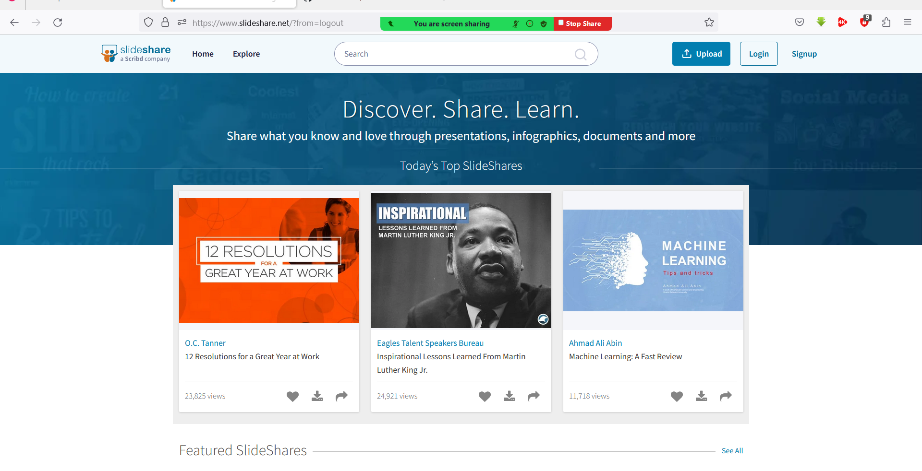

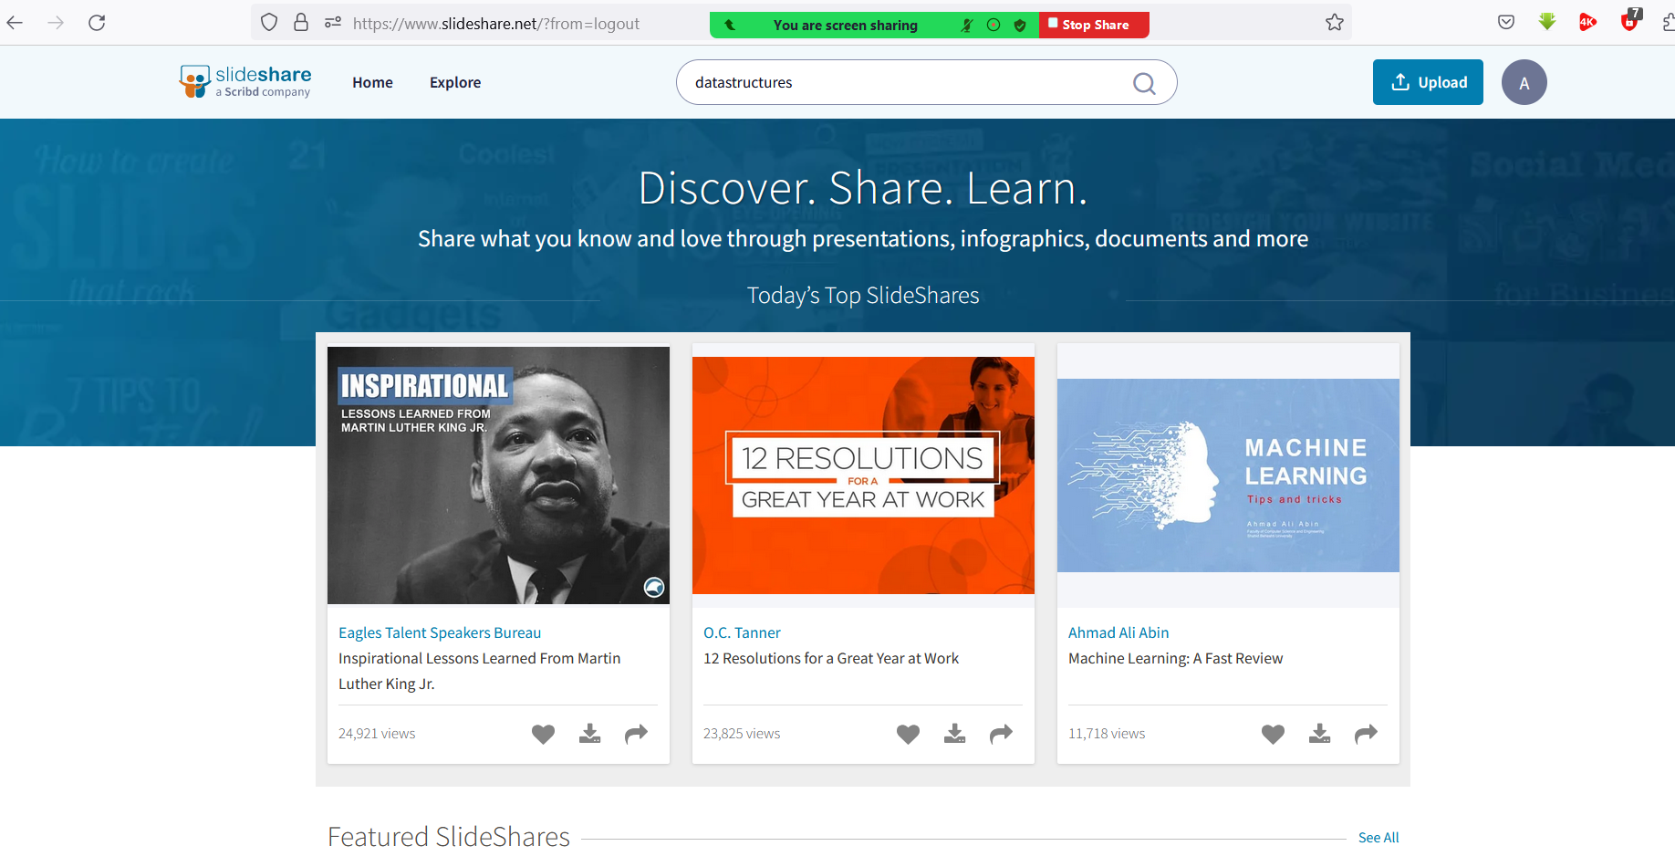

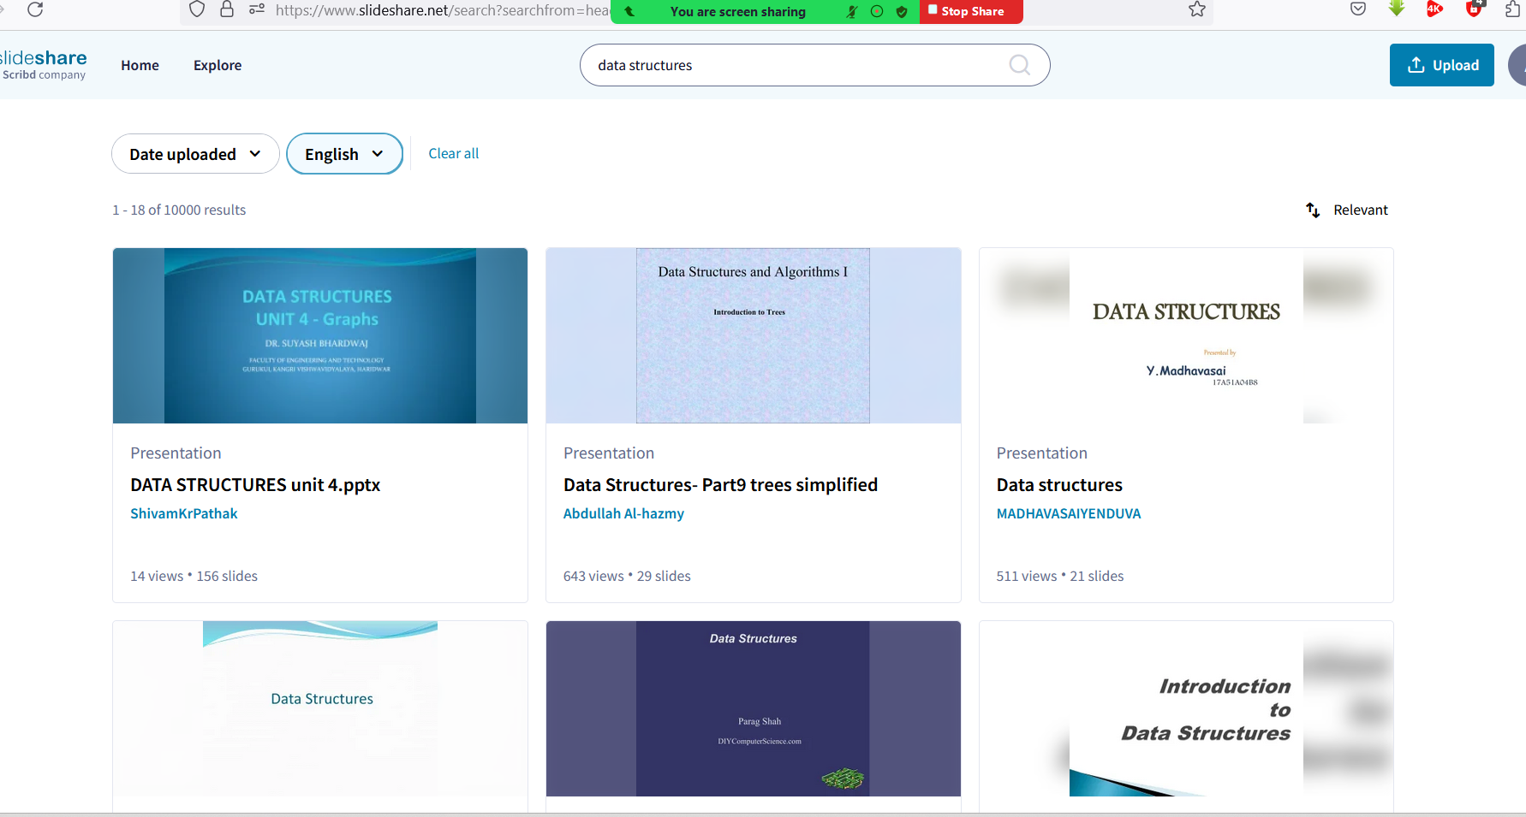

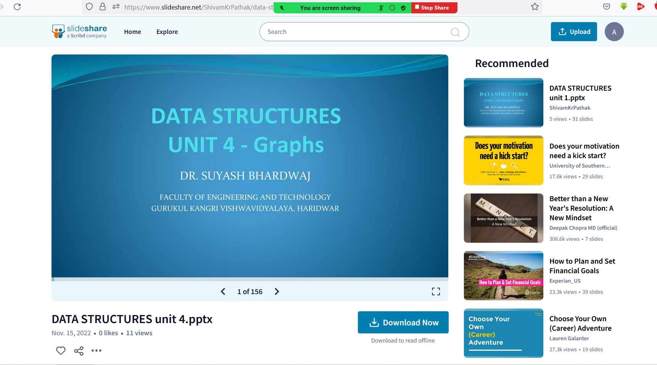

Section II – Git [10 marks]  
Question : Create a git repository version control system with minimum 3 branches in VS Code

and push the code in github. [5marks]

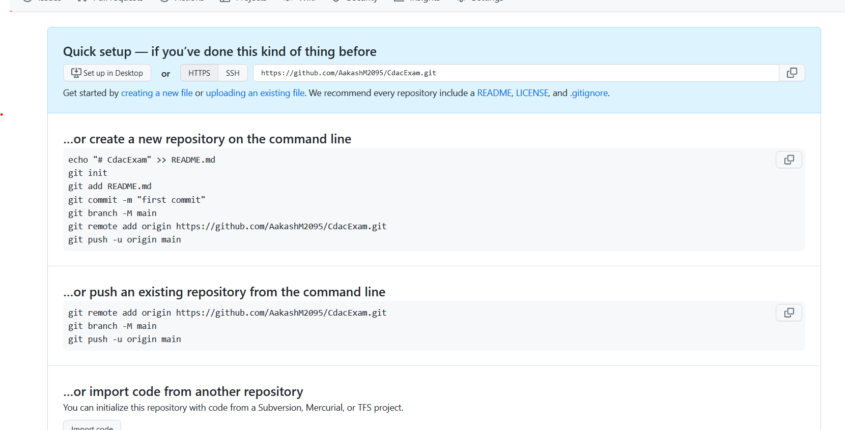

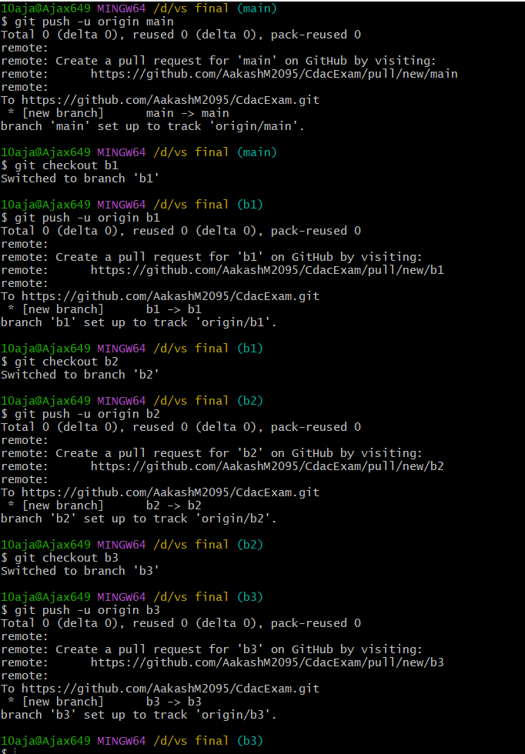

commit 1:Create java file with fibonacci series with 20 numbers and call commit.  
commit 2:Update java file with prime numers till 20 numbers code with switch case and call  
commit. [3marks]

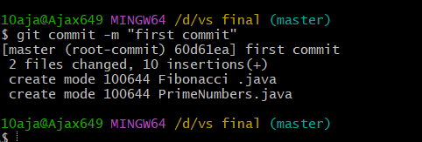

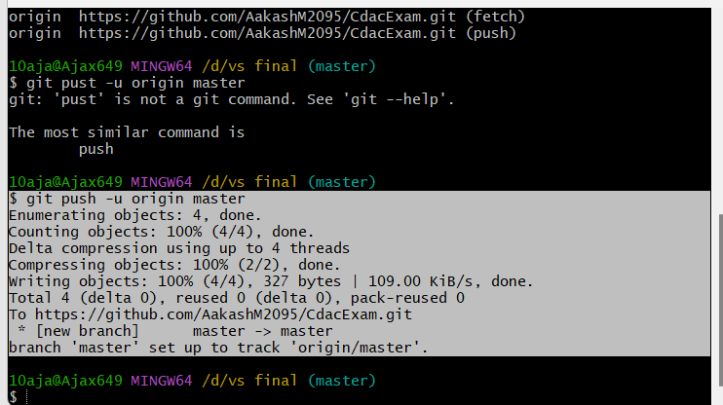  
commit 3 : Update java file with armstrong number code with switch case and call commit.  
[2marks]

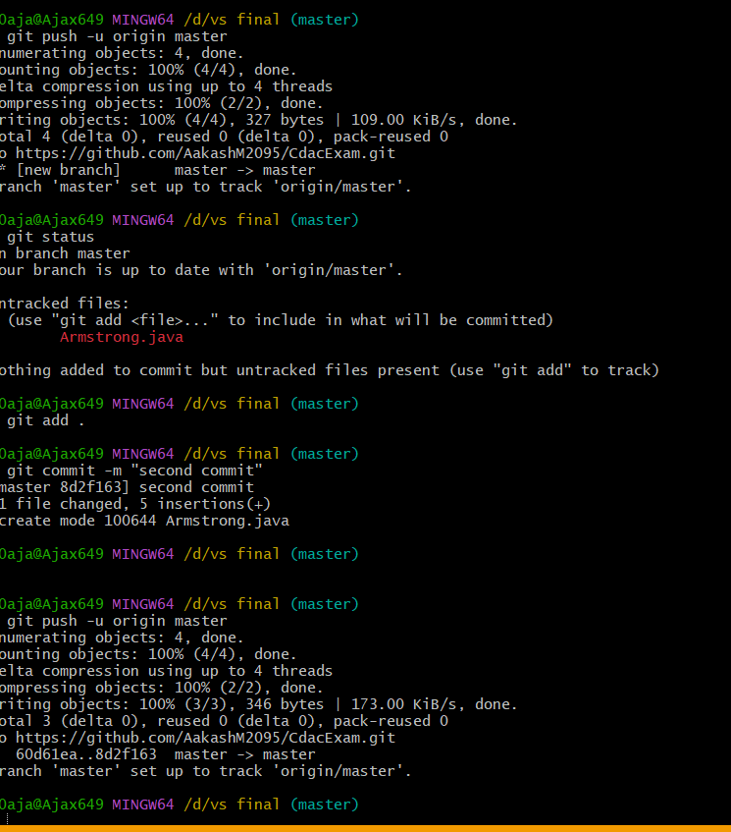  
Run the git command to update status after each commit.